**Assignment 18.3:**

Loading File:



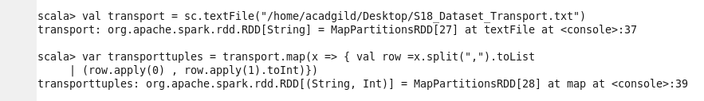



1. Considering age groups of <20 , 20-35 , 35> which age group spends the most amount of money travelling

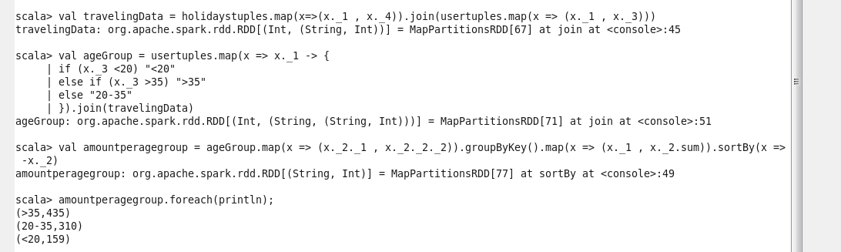

1. What is the amount spent by each age-group, every year in travelling?



